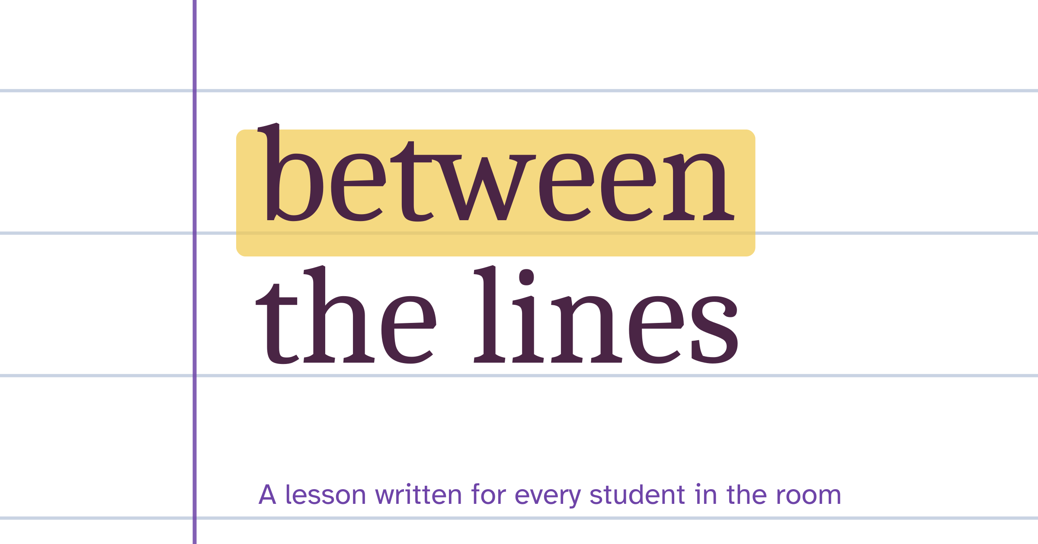
FREE LESSON SAMPLER
A Christmas Carol:
Meet Scrooge
How does Dickens make us dislike Scrooge, and why does he want us to?
Lesson 3 of 24 from the scheme of learning
Teacher notes, slides and student pages at all three levels
Written for the AQA specification

© 2026 Between the Lines. This sampler is free to use and print in your school. Please share the link to our website instead of the file.

What is in this sampler
This is one complete lesson from our A Christmas Carol scheme for Literature Paper 1, Section B. It comes exactly as it appears in the full scheme, so you can teach it next week and see how our lessons work.
Teacher notes | Timings with slide numbers, Do Now answers, the exploded quotation, the hinge question and what each answer tells you, the task at three levels, a model paragraph and notes on misconceptions and adapting the lesson (next pages).
Slides | The editable PowerPoint deck for Lesson 3, with teacher notes on every slide (separate file).
Student pages | The lesson’s pages from the Securing, Strengthening and Soaring student packs: one question, three levels of support (at the end of this document).

How every lesson works
Know | Do Now from memory, vocabulary, then the reading.
Apply | Explode one quotation together; a hinge question checks understanding.
Master | One shared question answered as a What–How–Why paragraph, with Securing, Strengthening and Soaring support; then a model paragraph and an exit ticket.

In the full scheme
- 24 lessons like this one, with editable slides and a teacher handbook
- Student packs at three levels for every lesson
- Six weeks of deliberate practice homework at three levels
- Four Feedback Loop mini assessments with whole-class feedback sheets and improvement tasks
- An exam-style end-of-unit essay with level guidance and three annotated model answers

Lesson 3: Meet Scrooge
SEQUENCE 1: CONTEXT AND STAVE 1 · 60 MINUTES
How does Dickens make us dislike Scrooge, and why does he want us to?

By the end of the lesson, students can
- Explain three methods Dickens uses to introduce Scrooge
- Link Scrooge’s coldness to Dickens’s purpose
- Write a What–How–Why paragraph on the opening of Stave 1

Lesson at a glance
Time | Phase | What happens | Slides
0–8 | Know | Do Now: five quick questions on Lessons 1 and 2. Students self-mark from the answer slide. | 2–3
8–18 | Know | Pre-teach covetous, flint and solitary. Read the extract aloud while students follow. | 4–5
18–28 | Apply | Explode the quotation together. Think aloud about the simile, then students annotate their copy. | 6
28–33 | Apply | Hinge question on mini-whiteboards. Use the answers to decide who starts on which level of support. | 7–8
33–53 | Master | Students write one What–How–Why paragraph using the student pack at their level. Share the model paragraph in the last five minutes. | 9–10
53–60 | Master | Exit ticket. Collect and sort into three piles to plan the start of Lesson 4. | 11

Do Now answers
1 | In which year was A Christmas Carol published? | 1843
2 | What did the 1834 Poor Law make the main form of help for poor people? | The workhouse
3 | Which thinker argued that population grows faster than the food supply? | Thomas Malthus
4 | The novella is divided into five sections called ________. | Staves (a stave is a verse of a song, which links to the idea of a carol)
5 | Name one thing Dickens saw or read in 1843 that made him want to write about poverty. | Any one of: the government report on children’s working conditions; his visit to the Field Lane Ragged School; the poverty he saw in Manchester

Vocabulary
covetous | greedy for things that belong to other people
flint | a very hard grey stone that makes sparks when struck with steel
solitary | alone, without company
self-contained | keeping your thoughts and feelings to yourself; needing no one else

Reading
Stave 1: Dickens introduces Scrooge
The narrator describes Scrooge for the first time.
Oh! But he was a tight-fisted hand at the grindstone, Scrooge! a squeezing, wrenching, grasping, scraping, clutching, covetous, old sinner! Hard and sharp as flint, from which no steel had ever struck out generous fire; secret, and self-contained, and solitary as an oyster. The cold within him froze his old features, nipped his pointed nose, shrivelled his cheek, stiffened his gait; made his eyes red, his thin lips blue; and spoke out shrewdly in his grating voice. A frosty rime was on his head, and on his eyebrows, and his wiry chin. He carried his own low temperature always about with him; he iced his office in the dog-days; and didn’t thaw it one degree at Christmas.
Charles Dickens, A Christmas Carol (1843), Stave 1
Word help grindstone: a stone wheel for sharpening tools; here, hard work that never stops · rime: frost · dog-days: the hottest days of summer

Explode the quotation
Method  A simile that compares Scrooge to a shellfish. | Zoom in  “solitary” means alone. Dickens shows that Scrooge chooses to shut people out.
“solitary as an oyster”
Effect  An oyster is clamped shut and hard to open, so readers see Scrooge as closed off and cold. | Purpose  An oyster can hide a pearl. Dickens hints that something precious is locked inside Scrooge, which prepares us for his change.

Hinge question
Dickens calls Scrooge “solitary as an oyster”. Which reading does the text best support?
A. Scrooge is precious, like a pearl.
B. Scrooge is closed off, but something good may be hidden inside. (the right answer)
C. Scrooge prefers to live by the sea.

What the answers tell you
A means the student is reading the image but missing “solitary”: recap the word before they write. C is a literal reading: start these students on Securing.
Why the answer is right
“solitary” tells us Scrooge shuts people out, and an oyster can hide a pearl, so Dickens hints that he could change.

Master task
How does Dickens present Scrooge as cut off from other people?

Securing aiming for a 4  Quotations to choose from  “solitary as an oyster”  “Hard and sharp as flint”  “The cold within him froze his old features”  Starters  Dickens presents Scrooge as ____. Dickens writes ____. The word ____ suggests ____. Dickens wants his readers to ____ because ____. | Strengthening aiming for grades 5 to 6  Prompts  What: Make a clear point that answers the question.  How: Choose a quotation. Name the method (simile, list, imagery) and zoom in on one word.  Why: What did Dickens want readers in 1843 to think about people like Scrooge? Use what you learned about the Poor Law in Lesson 1. | Soaring aiming for grades 7 to 9  The debate  “Scrooge chose his isolation. How far do you agree?”  Write two paragraphs. In the second, give an alternative reading that begins with Alternatively.

Model paragraph
What | Dickens presents Scrooge as a man who has deliberately shut himself away from other people.
How | The narrator describes him as “secret, and self-contained, and solitary as an oyster”. The repeated “and” piles up words of isolation, while the simile compares Scrooge to a creature that clamps its shell tight against the world.
Why | Dickens makes the coldness come from “within him”, so readers understand that Scrooge’s loneliness is a choice. Yet an oyster can hold a pearl, so the image quietly suggests that a better man is locked inside, waiting to be opened by the spirits.

Exit ticket
Dickens makes Scrooge cold so that…

Teacher notes
Subject knowledge
The description is built on lists. In “a squeezing, wrenching, grasping, scraping, clutching, covetous, old sinner” the five -ing words pile up with no “and”, so the greed feels relentless. Flint makes a spark only when struck with steel: Scrooge has never been “struck” into generosity. The cold imagery is internal (“The cold within him”) and outlasts the weather, which matters later when warmth and light mark his change.
Common misconceptions
- Retelling what Scrooge does instead of how Dickens presents him.
- Naming a simile with no effect attached.
- Treating Scrooge as simply evil, when Dickens needs him to be capable of change.
- Adding context at the end instead of linking it to Dickens’s purpose.
Adapting the lesson
Everyone answers the same question on the same extract. Students who chose C in the hinge question, or who struggled with the Do Now, start on Securing. Move anyone who completes the Securing frame in ten minutes to the Strengthening prompts for a second paragraph. Students who can already build a thesis start on Soaring.

LESSON  3 | Meet Scrooge  How does Dickens make us dislike Scrooge, and why does he want us to? | Securing  aiming for a 4

Do Now: five quick questions
1 | In which year was A Christmas Carol published?
2 | What did the 1834 Poor Law make the main form of help for poor people?
3 | Which thinker argued that population grows faster than the food supply?
4 | The novella is divided into five sections called ________.
5 | Name one thing Dickens saw or read in 1843 that made him want to write about poverty.

Vocabulary
covetous | greedy for things that belong to other people
flint | a very hard grey stone that makes sparks when struck with steel
solitary | alone, without company
self-contained | keeping your thoughts and feelings to yourself; needing no one else

Reading
Stave 1: Dickens introduces Scrooge
The narrator describes Scrooge for the first time.
Oh! But he was a tight-fisted hand at the grindstone, Scrooge! a squeezing, wrenching, grasping, scraping, clutching, covetous, old sinner! Hard and sharp as flint, from which no steel had ever struck out generous fire; secret, and self-contained, and solitary as an oyster. The cold within him froze his old features, nipped his pointed nose, shrivelled his cheek, stiffened his gait; made his eyes red, his thin lips blue; and spoke out shrewdly in his grating voice. A frosty rime was on his head, and on his eyebrows, and his wiry chin. He carried his own low temperature always about with him; he iced his office in the dog-days; and didn’t thaw it one degree at Christmas.
Charles Dickens, A Christmas Carol (1843), Stave 1
Word help grindstone: a stone wheel for sharpening tools; here, hard work that never stops · rime: frost · dog-days: the hottest days of summer

Explode the quotation
Annotate each box as your teacher explodes the quotation.
Method | Zoom in
“solitary as an oyster”
Effect | Purpose

Your task
How does Dickens present Scrooge as cut off from other people?

Word bank
covetous | greedy for what other people have
flint | a very hard stone
solitary | alone, without company
grindstone | hard work that never stops

Choose your quotations
- “solitary as an oyster”
- “Hard and sharp as flint”
- “The cold within him froze his old features”

Worked example
Dickens presents Scrooge as mean. He calls him a “tight-fisted hand at the grindstone”, which suggests he holds on to his money and never lets it go.
The example uses a different quotation. Choose one from the list above for your own paragraph.

Your task
How does Dickens present Scrooge as cut off from other people?

Write your paragraph
What: Dickens presents Scrooge as ____.
How: Dickens writes ____. The word ____ suggests ____.
Why: Dickens wants his readers to ____ because ____.

Exit ticket
Dickens makes Scrooge cold so that…

LESSON  3 | Meet Scrooge  How does Dickens make us dislike Scrooge, and why does he want us to? | Strengthening  aiming for grades 5 to 6

Do Now: five quick questions
1 | In which year was A Christmas Carol published?
2 | What did the 1834 Poor Law make the main form of help for poor people?
3 | Which thinker argued that population grows faster than the food supply?
4 | The novella is divided into five sections called ________.
5 | Name one thing Dickens saw or read in 1843 that made him want to write about poverty.

Vocabulary
covetous | greedy for things that belong to other people
flint | a very hard grey stone that makes sparks when struck with steel
solitary | alone, without company
self-contained | keeping your thoughts and feelings to yourself; needing no one else

Reading
Stave 1: Dickens introduces Scrooge
The narrator describes Scrooge for the first time.
Oh! But he was a tight-fisted hand at the grindstone, Scrooge! a squeezing, wrenching, grasping, scraping, clutching, covetous, old sinner! Hard and sharp as flint, from which no steel had ever struck out generous fire; secret, and self-contained, and solitary as an oyster. The cold within him froze his old features, nipped his pointed nose, shrivelled his cheek, stiffened his gait; made his eyes red, his thin lips blue; and spoke out shrewdly in his grating voice. A frosty rime was on his head, and on his eyebrows, and his wiry chin. He carried his own low temperature always about with him; he iced his office in the dog-days; and didn’t thaw it one degree at Christmas.
Charles Dickens, A Christmas Carol (1843), Stave 1
Word help grindstone: a stone wheel for sharpening tools; here, hard work that never stops · rime: frost · dog-days: the hottest days of summer

Explode the quotation
Annotate each box as your teacher explodes the quotation.
Method | Zoom in
“solitary as an oyster”
Effect | Purpose

Your task
How does Dickens present Scrooge as cut off from other people?

What, How and Why
What | Make a clear point that answers the question.
How | Choose a quotation. Name the method (simile, list, imagery) and zoom in on one word.
Why | What did Dickens want readers in 1843 to think about people like Scrooge? Use what you learned about the Poor Law in Lesson 1.

Plan your paragraph
My point
answers the question
My quotation
short and exact
Method and zoom
the method, and the one word I will explore
Dickens’s purpose
what he wanted readers to think or do

Your task
How does Dickens present Scrooge as cut off from other people?

Write your paragraph

Check your paragraph
My point answers the question
I use a short, embedded quotation
I name a method and explain its effect
I zoom in on one word
I link to Dickens’s purpose as well as Scrooge’s personality

Exit ticket
Dickens makes Scrooge cold so that…

LESSON  3 | Meet Scrooge  How does Dickens make us dislike Scrooge, and why does he want us to? | Soaring  aiming for grades 7 to 9

Do Now: five quick questions
1 | In which year was A Christmas Carol published?
2 | What did the 1834 Poor Law make the main form of help for poor people?
3 | Which thinker argued that population grows faster than the food supply?
4 | The novella is divided into five sections called ________.
5 | Name one thing Dickens saw or read in 1843 that made him want to write about poverty.

Vocabulary
covetous | greedy for things that belong to other people
flint | a very hard grey stone that makes sparks when struck with steel
solitary | alone, without company
self-contained | keeping your thoughts and feelings to yourself; needing no one else

Reading
Stave 1: Dickens introduces Scrooge
The narrator describes Scrooge for the first time.
Oh! But he was a tight-fisted hand at the grindstone, Scrooge! a squeezing, wrenching, grasping, scraping, clutching, covetous, old sinner! Hard and sharp as flint, from which no steel had ever struck out generous fire; secret, and self-contained, and solitary as an oyster. The cold within him froze his old features, nipped his pointed nose, shrivelled his cheek, stiffened his gait; made his eyes red, his thin lips blue; and spoke out shrewdly in his grating voice. A frosty rime was on his head, and on his eyebrows, and his wiry chin. He carried his own low temperature always about with him; he iced his office in the dog-days; and didn’t thaw it one degree at Christmas.
Charles Dickens, A Christmas Carol (1843), Stave 1
Word help grindstone: a stone wheel for sharpening tools; here, hard work that never stops · rime: frost · dog-days: the hottest days of summer

Explode the quotation
Annotate each box as your teacher explodes the quotation.
Method | Zoom in
“solitary as an oyster”
Effect | Purpose

Your task
How does Dickens present Scrooge as cut off from other people?

The debate
“Scrooge chose his isolation. How far do you agree?”
Write two paragraphs. In the second, give an alternative reading that begins with Alternatively.
Think about
- What an oyster can hide, and what that might foreshadow
- How the cold “within him” connects to weather that cannot touch him
- How Scrooge echoes Malthus later in Stave 1
Verbs to try
insinuates · foreshadows · undercuts · intensifies

Plan your argument
My argument | An alternative reading

Your task
How does Dickens present Scrooge as cut off from other people?

Write your answer

Exit ticket
Dickens makes Scrooge cold so that…

