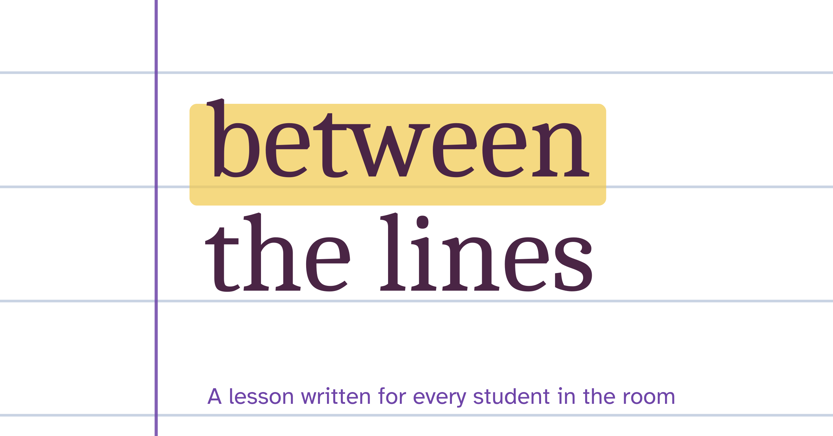
FREE LESSON SAMPLER
The Strange Case of Dr Jekyll and Mr Hyde:
Story of the door
How does Stevenson make Hyde’s first act shocking?
Lesson 3 of 34 from the scheme of learning
Teacher notes, slides and student pages at all three levels
Written for the AQA specification
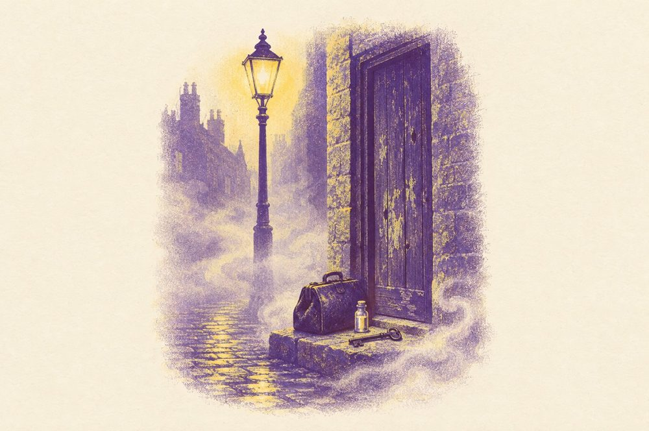

© 2026 Between the Lines. This sampler is free to use and print in your school. Please share the link to our website instead of the file.

What is in this sampler
This is one complete lesson from our The Strange Case of Dr Jekyll and Mr Hyde scheme for Literature Paper 1, Section B. It comes exactly as it appears in the full scheme, so you can teach it next week and see how our lessons work.
Teacher notes | Timings with slide numbers, Do Now answers, the exploded quotation, the hinge question and what each answer tells you, the task at three levels, a model paragraph and notes on misconceptions and adapting the lesson (next pages).
Slides | The editable PowerPoint deck for Lesson 3, with teacher notes on every slide (separate file).
Student pages | The lesson’s pages from the Securing, Strengthening and Soaring student packs: one question, three levels of support (at the end of this document).

How every lesson works
Know | Do Now from memory, vocabulary, then the reading.
Apply | Explode one quotation together; a hinge question checks understanding.
Master | One shared question answered as a What–How–Why paragraph, with Securing, Strengthening and Soaring support; then a model paragraph and an exit ticket.

In the full scheme
- 34 lessons like this one, with editable slides and a teacher handbook
- Student packs at three levels for every lesson
- Six weeks of independent practice homework at three levels
- Four Feedback Loop progress checks with whole-class feedback sheets and improvement tasks
- An exam-style end-of-unit essay with level guidance and three annotated model answers

Lesson 3: Story of the door
SEQUENCE 1: CONTEXT AND CHAPTERS 1 AND 2 · 60 MINUTES
How does Stevenson make Hyde’s first act shocking?

By the end of the lesson, students can
- Explain how Stevenson introduces Hyde through Enfield, a witness
- Analyse the Juggernaut simile and the adverb “calmly”
- Write a What–How–Why paragraph on Hyde’s attack on the girl

Lesson at a glance
Time | Phase | What happens | Slides
0–8 | Know | Do Now: five quick questions on Lesson 1 and the reading of Chapters 1 and 2. Students self-mark from the answer slide. | 2–3
8–18 | Know | Pre-teach trample, Juggernaut, hellish and callous. Read the extract aloud while students follow and underline everything Hyde does. | 4–6
18–28 | Apply | Explode the quotation together. Think aloud about why Enfield cannot describe Hyde as a man, then students annotate their copy. Before you reveal any notes, students try the four empty boxes on the first explode slide, on their own or after you model one box. | 7
28–33 | Apply | Hinge question on mini-whiteboards. Use the answers to decide who starts on which level of support. | 8–9
33–53 | Master | Students write one What–How–Why paragraph using the student pack at their level. Share the model paragraph in the last five minutes. | 10–11
53–60 | Master | Exit ticket. Collect and sort into three piles to plan the start of the next lesson. | 12

Do Now answers
1 | In which month and year was the novella published? | January 1886
2 | What is blackmail? | Demanding money from someone by threatening to reveal their secret
3 | What is Enfield’s rule about asking questions? | The more suspicious something looks, the less he asks
4 | Whose will leaves everything to Edward Hyde? | Dr Jekyll’s
5 | Who was Deacon Brodie? | A respected Edinburgh cabinet-maker and town councillor who was a burglar by night

Vocabulary
trample | to tread heavily on something and crush it
Juggernaut | a huge force that crushes everything in its path
hellish | like hell: terrible, cruel and evil
callous | cruel, and not caring about other people’s pain

Reading
Chapter 1: Enfield’s story
Enfield tells Utterson what he saw at “about three o’clock of a black winter morning”, walking home through empty, lamp-lit streets.
All at once, I saw two figures: one a little man who was stumping along eastward at a good walk, and the other a girl of maybe eight or ten who was running as hard as she was able down a cross street. Well, sir, the two ran into one another naturally enough at the corner; and then came the horrible part of the thing; for the man trampled calmly over the child’s body and left her screaming on the ground. It sounds nothing to hear, but it was hellish to see. It wasn’t like a man; it was like some damned Juggernaut. I gave a few halloa, took to my heels, collared my gentleman, and brought him back to where there was already quite a group about the screaming child. He was perfectly cool and made no resistance, but gave me one look, so ugly that it brought out the sweat on me like running.
Robert Louis Stevenson, The Strange Case of Dr Jekyll and Mr Hyde (1886), Chapter 1
Word help stumping: walking with short, heavy steps · halloa: a shout to get attention · collared: grabbed by the collar

Explode the quotation
Method  A simile. Enfield cannot describe Hyde as a man, so he compares him to a crushing force. | Zoom in  “Juggernaut” is a noun for a huge force that crushes whatever is in its path. The adjective “damned” adds hell to the image.
“like some damned Juggernaut”
Effect  Readers picture something heavy and unfeeling rolling over a child, which is more horrifying than anger would be. | Purpose  Enfield says “It wasn’t like a man”. From Hyde’s first act, Stevenson suggests he may not be fully human.

Hinge question
Enfield says Hyde was “like some damned Juggernaut”. What does the simile suggest about the attack?
A. Hyde crushed the child like an unstoppable force that feels nothing. (the right answer)
B. Hyde was driving a heavy cart when he ran into the girl.
C. Hyde was cursed, so he could not help what he did.

What the answers tell you
B is a literal reading: remind students that a simile compares, and start them on Securing. C has noticed “damned” but turns Hyde into a victim: point to “trampled calmly” and ask whether a man who could not help himself would be calm.
Why the answer is right
A Juggernaut crushes whatever is in its way without stopping, and Hyde tramples the girl “calmly”, without any feeling.

Master task
How does Stevenson make Hyde’s attack on the girl shocking?

Securing aiming for a 4  Quotations to choose from  “trampled calmly over the child’s body”  “left her screaming on the ground”  “it was hellish to see”  Starters  Stevenson makes the attack shocking by ____. Enfield says that Hyde ____. The ____ (adjective) ____ (word class) ____ suggests ____. Stevenson wants his readers to ____ because ____. | Strengthening aiming for grades 5 to 6  Prompts  What: Make a clear point about what makes the attack shocking.  How: Choose a quotation. Name the method (simile, verb choice, contrast) and zoom in on one word.  Why: What did Stevenson want his readers in 1886 to feel about Hyde from his very first act? Think about who the victim is and who tells the story. | Soaring aiming for grades 7 to 9  The debate  “Hyde’s calmness is more shocking than the attack itself. How far do you agree?”  Write two paragraphs. In the second, give an alternative reading that begins with Alternatively.

Model paragraph
What | Stevenson makes the attack shocking because Hyde hurts a child without showing any feeling at all.
How | Enfield says that Hyde “trampled calmly over the child’s body”. The violent verb “trampled” sits beside the quiet adverb “calmly”, so the cruelty seems effortless. Enfield then calls him “like some damned Juggernaut”, a simile that turns Hyde into a machine that crushes whatever lies in its path.
Why | Stevenson gives the story to Enfield, a respectable man about town, who can only reach for the language of hell: it was “hellish to see”. Readers in 1886 meet Hyde first as something less than human, and the victim, a small girl, makes the act impossible to excuse.

Exit ticket
Hyde’s calmness is frightening because…

Teacher notes
Subject knowledge
Enfield tells the story at second hand, in his own chatty voice (“Well, sir”), which makes the horror feel like real testimony. The setting builds tension first: streets “as empty as a church” and Enfield beginning “to long for the sight of a policeman”. The girl is “not much the worse”, so the horror lies in Hyde’s manner. Everyone who sees Hyde wants to hurt him, even the doctor who is “about as emotional as a bagpipe”, a dry joke that makes his hatred more striking. Hyde then pays with a cheque signed by a respectable man, which turns an assault into a mystery.
Common misconceptions
- Thinking Hyde killed or badly injured the girl. She is “not much the worse”; the horror is in how he behaves.
- Picturing a juggernaut as a lorry. In 1886 the word meant a huge force that crushes everything before it.
- Retelling Enfield’s story instead of analysing Stevenson’s words.
- Forgetting that this is Enfield’s account: readers see Hyde through a witness, never directly.
Adapting the lesson
Everyone answers the same question on the same extract. Students who chose B or C in the hinge question, or who struggled with the Do Now, start on Securing. Move anyone who completes the Securing frame in ten minutes to the Strengthening prompts for a second paragraph. Students who can already build a thesis start on Soaring.
Inclusion
Pre-teach | Juggernaut and trample, with a picture of a steamroller or a huge cart, and the idea of a witness telling a story at second hand.
SEND | Give an enlarged copy of the extract with Hyde’s actions underlined in one colour and Enfield’s reactions in another. Students choose one of the three Securing quotations and stick it in.
EAL | Gloss halloa, collared and stumping beside the extract. Explain that damned and hellish are strong religious words here, not casual swearing. Rehearse the What sentence aloud in pairs before writing.
Pupil premium | Ask these students first on the hinge question. Talk about why a respectable witness like Enfield would be believed in court, so they see why Stevenson tells the story through him.

LESSON  3 | Story of the door  How does Stevenson make Hyde’s first act shocking? | Securing  aiming for a 4

Do Now: five quick questions
1 | In which month and year was the novella published?
2 | What is blackmail?
3 | What is Enfield’s rule about asking questions?
4 | Whose will leaves everything to Edward Hyde?
5 | Who was Deacon Brodie?

Vocabulary
trample | to tread heavily on something and crush it
Juggernaut | a huge force that crushes everything in its path
hellish | like hell: terrible, cruel and evil
callous | cruel, and not caring about other people’s pain

Reading
Chapter 1: Enfield’s story
Enfield tells Utterson what he saw at “about three o’clock of a black winter morning”, walking home through empty, lamp-lit streets.
All at once, I saw two figures: one a little man who was stumping along eastward at a good walk, and the other a girl of maybe eight or ten who was running as hard as she was able down a cross street. Well, sir, the two ran into one another naturally enough at the corner; and then came the horrible part of the thing; for the man trampled calmly over the child’s body and left her screaming on the ground. It sounds nothing to hear, but it was hellish to see. It wasn’t like a man; it was like some damned Juggernaut. I gave a few halloa, took to my heels, collared my gentleman, and brought him back to where there was already quite a group about the screaming child. He was perfectly cool and made no resistance, but gave me one look, so ugly that it brought out the sweat on me like running.
Robert Louis Stevenson, The Strange Case of Dr Jekyll and Mr Hyde (1886), Chapter 1
Word help stumping: walking with short, heavy steps · halloa: a shout to get attention · collared: grabbed by the collar

Explode the quotation
Try each box on your own first. Then add to it as your teacher explodes the quotation.
Method | Zoom in
“like some damned Juggernaut”
Effect | Purpose

Your task
How does Stevenson make Hyde’s attack on the girl shocking?

Word bank
trample | to tread on and crush
callous | cruel and uncaring
innocent | having done nothing wrong
inhuman | without the feelings a human should have

Choose your quotations
- “trampled calmly over the child’s body”
- “left her screaming on the ground”
- “it was hellish to see”

Worked example
Stevenson makes the empty streets feel tense. Enfield says they were “as empty as a church”, which suggests a silence where something terrible could happen with no one there to stop it.
The example uses a different quotation. Choose one from the list above for your own paragraph.

Your task
How does Stevenson make Hyde’s attack on the girl shocking?

Write your paragraph
What: Stevenson makes the attack shocking by ____.
How: Enfield says that Hyde ____. The ____ (adjective) ____ (word class) ____ suggests ____.
Why: Stevenson wants his readers to ____ because ____.

Exit ticket
Hyde’s calmness is frightening because…

LESSON  3 | Story of the door  How does Stevenson make Hyde’s first act shocking? | Strengthening  aiming for grades 5 to 6

Do Now: five quick questions
1 | In which month and year was the novella published?
2 | What is blackmail?
3 | What is Enfield’s rule about asking questions?
4 | Whose will leaves everything to Edward Hyde?
5 | Who was Deacon Brodie?

Vocabulary
trample | to tread heavily on something and crush it
Juggernaut | a huge force that crushes everything in its path
hellish | like hell: terrible, cruel and evil
callous | cruel, and not caring about other people’s pain

Reading
Chapter 1: Enfield’s story
Enfield tells Utterson what he saw at “about three o’clock of a black winter morning”, walking home through empty, lamp-lit streets.
All at once, I saw two figures: one a little man who was stumping along eastward at a good walk, and the other a girl of maybe eight or ten who was running as hard as she was able down a cross street. Well, sir, the two ran into one another naturally enough at the corner; and then came the horrible part of the thing; for the man trampled calmly over the child’s body and left her screaming on the ground. It sounds nothing to hear, but it was hellish to see. It wasn’t like a man; it was like some damned Juggernaut. I gave a few halloa, took to my heels, collared my gentleman, and brought him back to where there was already quite a group about the screaming child. He was perfectly cool and made no resistance, but gave me one look, so ugly that it brought out the sweat on me like running.
Robert Louis Stevenson, The Strange Case of Dr Jekyll and Mr Hyde (1886), Chapter 1
Word help stumping: walking with short, heavy steps · halloa: a shout to get attention · collared: grabbed by the collar

Explode the quotation
Try each box on your own first. Then add to it as your teacher explodes the quotation.
Method | Zoom in
“like some damned Juggernaut”
Effect | Purpose

Your task
How does Stevenson make Hyde’s attack on the girl shocking?

What, How and Why
What | Make a clear point about what makes the attack shocking.
How | Choose a quotation. Name the method (simile, verb choice, contrast) and zoom in on one word.
Why | What did Stevenson want his readers in 1886 to feel about Hyde from his very first act? Think about who the victim is and who tells the story.

Plan your paragraph
My point
answers the question
My quotation
short and exact
Method and zoom
the method, and the one word I will explore
Stevenson’s purpose
what he wanted readers to think or do

Your task
How does Stevenson make Hyde’s attack on the girl shocking?

Write your paragraph

Check your paragraph
My point answers the question
I use a short, embedded quotation
I name a method and explain its effect
I zoom in on one word and name its word class
I explain why Stevenson makes the victim a child

Exit ticket
Hyde’s calmness is frightening because…

LESSON  3 | Story of the door  How does Stevenson make Hyde’s first act shocking? | Soaring  aiming for grades 7 to 9

Do Now: five quick questions
1 | In which month and year was the novella published?
2 | What is blackmail?
3 | What is Enfield’s rule about asking questions?
4 | Whose will leaves everything to Edward Hyde?
5 | Who was Deacon Brodie?

Vocabulary
trample | to tread heavily on something and crush it
Juggernaut | a huge force that crushes everything in its path
hellish | like hell: terrible, cruel and evil
callous | cruel, and not caring about other people’s pain

Reading
Chapter 1: Enfield’s story
Enfield tells Utterson what he saw at “about three o’clock of a black winter morning”, walking home through empty, lamp-lit streets.
All at once, I saw two figures: one a little man who was stumping along eastward at a good walk, and the other a girl of maybe eight or ten who was running as hard as she was able down a cross street. Well, sir, the two ran into one another naturally enough at the corner; and then came the horrible part of the thing; for the man trampled calmly over the child’s body and left her screaming on the ground. It sounds nothing to hear, but it was hellish to see. It wasn’t like a man; it was like some damned Juggernaut. I gave a few halloa, took to my heels, collared my gentleman, and brought him back to where there was already quite a group about the screaming child. He was perfectly cool and made no resistance, but gave me one look, so ugly that it brought out the sweat on me like running.
Robert Louis Stevenson, The Strange Case of Dr Jekyll and Mr Hyde (1886), Chapter 1
Word help stumping: walking with short, heavy steps · halloa: a shout to get attention · collared: grabbed by the collar

Explode the quotation
Try each box on your own first. Then add to it as your teacher explodes the quotation.
Method | Zoom in
“like some damned Juggernaut”
Effect | Purpose

Your task
How does Stevenson make Hyde’s attack on the girl shocking?

The debate
“Hyde’s calmness is more shocking than the attack itself. How far do you agree?”
Write two paragraphs. In the second, give an alternative reading that begins with Alternatively.
Think about
- Why Enfield says “It sounds nothing to hear, but it was hellish to see”
- How Hyde’s “one look” affects Enfield, a grown man
- Why the girl is “not much the worse”, and the scene still horrifies everyone who saw it
Verbs to try
dehumanises · juxtaposes · intensifies · foreshadows

Plan your argument
My argument | Testing it: another reading

Your task
How does Stevenson make Hyde’s attack on the girl shocking?

Write your answer

Exit ticket
Hyde’s calmness is frightening because…

